Connecting to SQL Server
Configuring the database

Linking to the Database 1
Before you Begin 1
SQL Server 1
How this will Work – Copy and Adapt 1
Creating your Account 1
Creating your Database 2
Managing your Database 2
Accessing the Database in Visual Studio 2
Creating Tables 4
Adding Data 11
Creating Stored Procedures 11
Testing the Stored Procedure 13

Linking to the Database

Before you Begin
Make sure that you have completed the work for last week and that you have watched the eLectures for this week before starting this work.

SQL Server
As a student you have access to a free SQL Server account.
I would suggest that in your team you nominate one person who is going to be the account holder. It is on their p number that the database needs to be created.
This person will create an SQL server database with a username and password which need to be distributed to members of the team. Do not use your normal DMU login password for this!
Working as a team, SQL Server provides the big advantage that each team member may connect to and use the database simultaneously. In other alternative configurations there is the risk of having multiple copies of the same data (one database for each team member) along with the risk of locking all members out of the system while one person is editing the schema.
Currently the SQL server database is only available within the DMU campus so each member must run their work using the My DMU Lab URL…
https://yourdmulabs.dmu.ac.uk

How this will Work – Copy and Adapt
In these notes I will present you with examples of what your code might look like. I will typically use the example of creating an Address Book. You are likely to be working on something quite different though. If you are working on the stock part of your system you will need to adapt my examples such that they work for you. Do not simply copy my examples as they stand!

Creating your Account
To create your database, you will need to access the server here…
https://g677.dmu.ac.uk/g677/
Once logged in you should see a tile as follows…

Click the tile to access the next step.

Creating your Database
The following screen allows you to create your database…
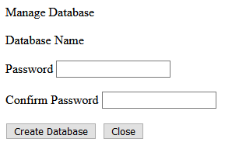
Then press create database.

Managing your Database
There are four different systems we need to configure in order to access your database, they are...
- The SQL Teams Portal – if you forget the password and need to change it
- Visual Studio – for creating and managing tables, stored procedures
- Data Connection Class – allowing your code to access the functionality provided by your stored procedures
- SQL Connect – a program to manage authentication of a secure connection

Accessing the Database in Visual Studio
For each team member to access the database they will need the name of the server, username and password created above. (You should have made a note of this.)
In the SQL Server Object Explorer right click on SQL Server and click Add SQL Server...
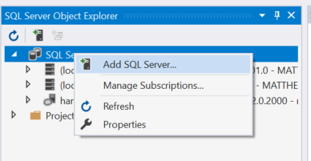
This will provide you with the following log in page...
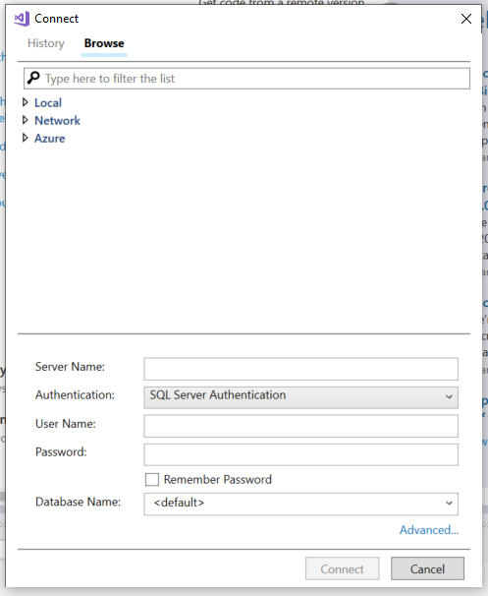
Make sure that authentication is set to SQL Server Authentication.
The Server Name is
v00egd00001l.lec-admin.dmu.ac.uk
Username and Password are those created by the database owner, and then press connect.
Try accessing the database through Visual Studio and you should now be able to navigate the structure...
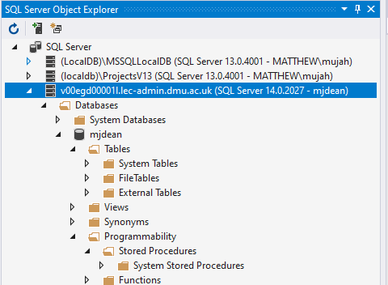

At this stage expand the sections for “Tables” along with “Programmability – Stored Procedures”. The will be currently blank

Creating Tables
The next resource we need to create is a table to store some data in.
From the SQL Server Object Explorer, right click on the section marked tables selecting “Add New Table”...
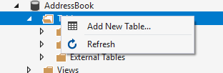
After a bit of waiting you will be presented with the following screen...
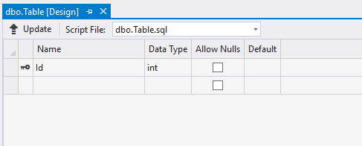
We will set up a basic table to store our list of counties.
First, set the name of the table by modifying the SQL at the bottom of the window setting the table name to tblAddress...
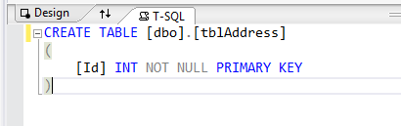
(“tbl” is just a naming table to remind us that this is a table!)
The next step is to create the fields for the table in the top section like so...
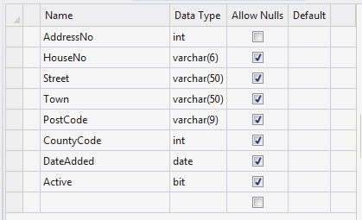
The column called Name identifies what the name of the data stored in the field. The column called data type identifies what sort of data we are allowed to store in that field.
For example,

Int short for Integer meaning whole numbers. E.g. 1,2,3,-40, 100 NOT 4.5, 55.8 as these are decimal numbers.

Varchar(6) Any combination of letters or numbers up to 6 characters

Date Any valid data

Bit True or False only

When creating field names, it is always a good idea to consider the following:
Avoid spaces AddressNo is better than Address No
Avoid unusual characters # ~ ! etc..
Use pascal naming convention AddressNo clearer than addressno
Avoid certain reserved words date, password (+ others)
Now that the fields have been set up we need to do two more things.
The field AddressNo is going to be the primary key for this table and will be used to uniquely identify each record in the table.
The first step is to make sure this value is unique. To do this we set it as the identity of the table so that the database will generate this value.
Click once in the name of the field to select it...
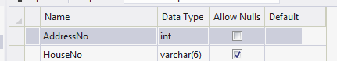
In the bottom, right hand corner of the program are the properties for the field. Find the property called Identity Specification and expand it...
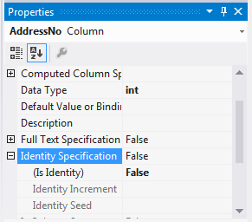
Change “Is Identity” from False to True like so...
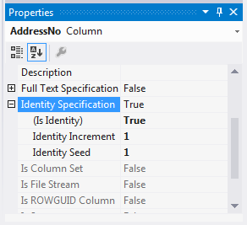
This has set the field such it starts at 1 (identity seed) and for every new record the numeric value increases by 1 (identity increment).
The last step is to set this field as the Primary Key for this table.
Right click to the left of the field name and select Set Primary Key...
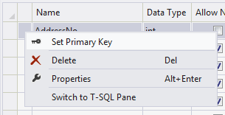
The definition for the table should now look like this...
CREATE TABLE [dbo].[tblAddress] (
[AddressNo] INT NOT NULL IDENTITY,
[HouseNo] VARCHAR (6) NULL,
[Street] VARCHAR (50) NULL,
[Town] VARCHAR (50) NULL,
[PostCode] VARCHAR (9) NULL,
[CountyCode] INT NULL,
[DateAdded] DATE NULL,
[Active] BIT NULL,
CONSTRAINT [PK_tblAddress] PRIMARY KEY ([AddressNo])
);
Now that the code to create the table is set up we need to create the table.
In Visual Studio press the button that says Update...
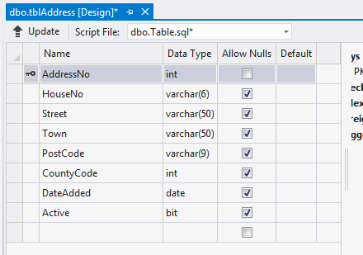
After a second or two the following screen should appear...
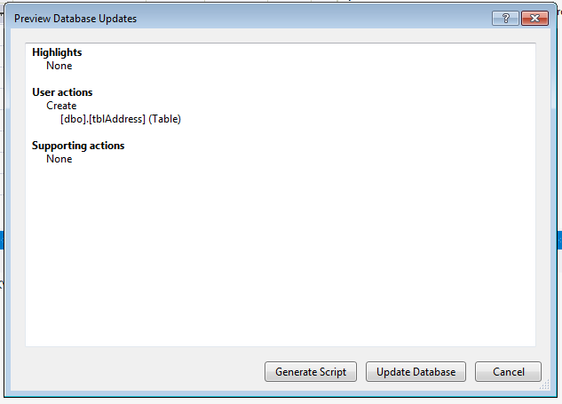

To create the new table, press Update Database.
Your table should now be visible, if not right click on the tables branch and select refresh...
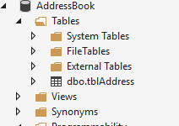

Adding Data
The next step is to add some data to your table to make sure it is working.
In the server explorer right click on the name of the table and select show table data.
This will give you a screen allowing you to add new data to the table.
Notice as you add the data the value for the AddressNo field is updated automatically by the database...
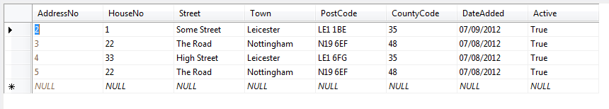
Add a few records so that we have some data for the next stage of the work.

Creating Stored Procedures
As mentioned above we will not be accessing the table directly with our code but using a stored procedure. One of the biggest advantages of this approach is that of increased security.
Creating a stored procedure is a very similar process to creating a table.
In the SQL Object Browser right click on the stored procedure branch and select “Add New Stored Procedure...”
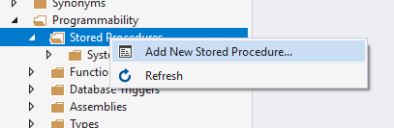
After a little while you should see the following screen appear...
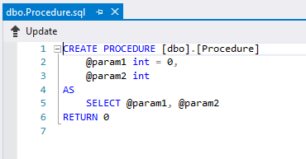
Modify the SQL code as follows...
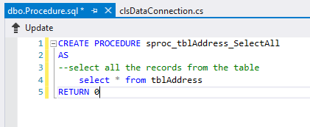
As in the case of a table you must press update to make the changes to the database structure.
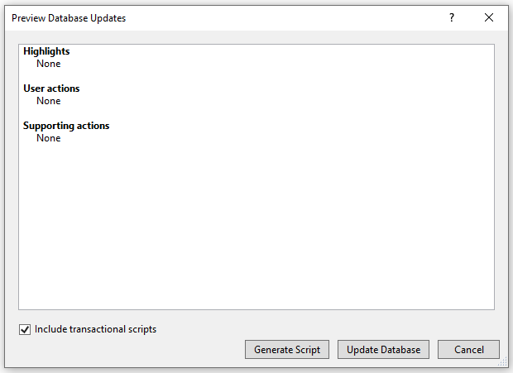
You should see the stored procedure in the tree structure of the database, if not try refreshing it...
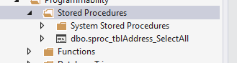

Testing the Stored Procedure
To make sure the stored procedure is working right click on it like so...
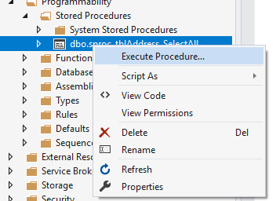
You should see the data from the underlying table displayed.
Close the query output window, don’t bother saving it.

